
Institute of Information Technology
Jahangirnagar University
Savar, Dhaka-1342

LAB REPORT
Course Code: ICT-3102
Course Title: Operating System Lab
Lab Report: 1
Lab Report Name: Installing Ubuntu on VirtualBox

Submitted to:
Mehrin Anannya
Assistant Professor
Institute of Information Technology
Jahangirnagar University

Submitted by:
Md. Shaon Khan
ID: 1984
Session: 2022-2023
Batch: 52

Lab Report
Installing Ubuntu on VirtualBox
Course: Operating System Lab

Introduction
In this lab, I installed Ubuntu Linux on a virtual machine using Oracle VirtualBox 7.2.6. VirtualBox is a free software that lets us run another operating system inside our current operating system. I used Windows as my host OS and installed Ubuntu 22.04.1 (64-bit) as the guest OS. The main goal of this lab was to learn how to set up VirtualBox, create a new virtual machine, configure its hardware, and install Ubuntu from an ISO image. I followed all the steps one by one and took screenshots at each important step. This report shows those screenshots with a short description for each one.

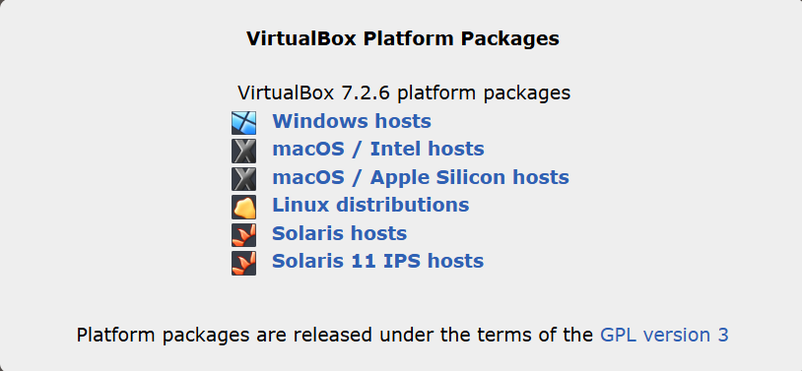
Steps with Screenshots
Figure 1: VirtualBox Platform Packages Download Page

This page shows the download options for VirtualBox 7.2.6. It has different packages for Windows, macOS, Linux, and Solaris. I selected the Windows hosts option to download VirtualBox for my Windows computer.

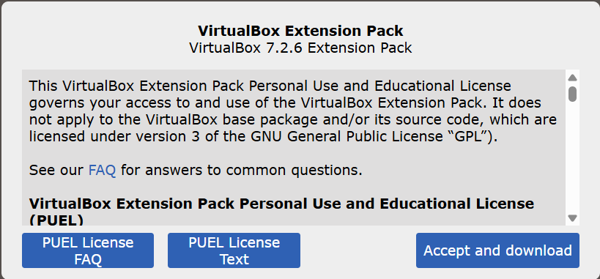
Figure 2: VirtualBox Extension Pack License Page

This is the VirtualBox 7.2.6 Extension Pack download page. It shows the license agreement for personal and educational use. I clicked "Accept and download" to download the extension pack.

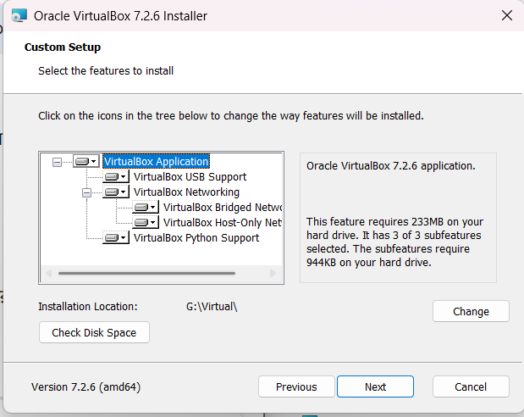
Figure 3: Custom Setup – First Directory Selection

This is the Custom Setup screen. It shows all the features available to install such as VirtualBox USB Support, Networking, Bridged Network, Host-Only Network, and Python Support. Here I selected G:\Virtual\ as the installation location.

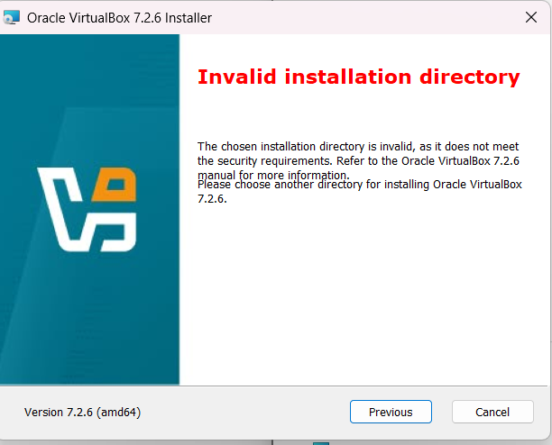
Figure 4: Invalid Installation Directory Error
When I first tried to install VirtualBox, this error appeared. It said the chosen installation directory is invalid because it does not meet security requirements. I had to go back and choose a different directory.

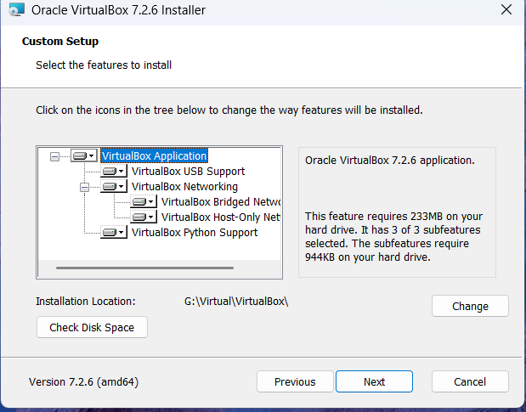
Figure 5: Custom Setup – Corrected Installation Directory
After fixing the directory error, I changed the installation path to G:\Virtual\VirtualBox\. This time the installer accepted the location. I clicked Next to continue with the installation.

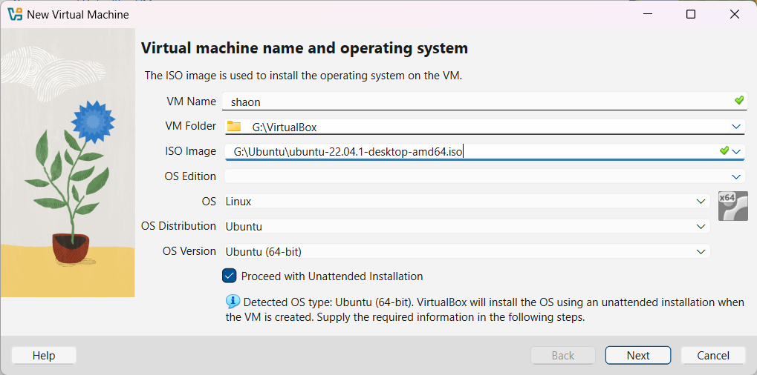
Figure 6: New Virtual Machine – Name and OS Selection

This screen is for creating a new virtual machine. I entered the VM name as "shaon" and set the folder to G:\VirtualBox. I also selected the Ubuntu 22.04.1 desktop ISO image. VirtualBox automatically detected the OS type as Ubuntu 64-bit.

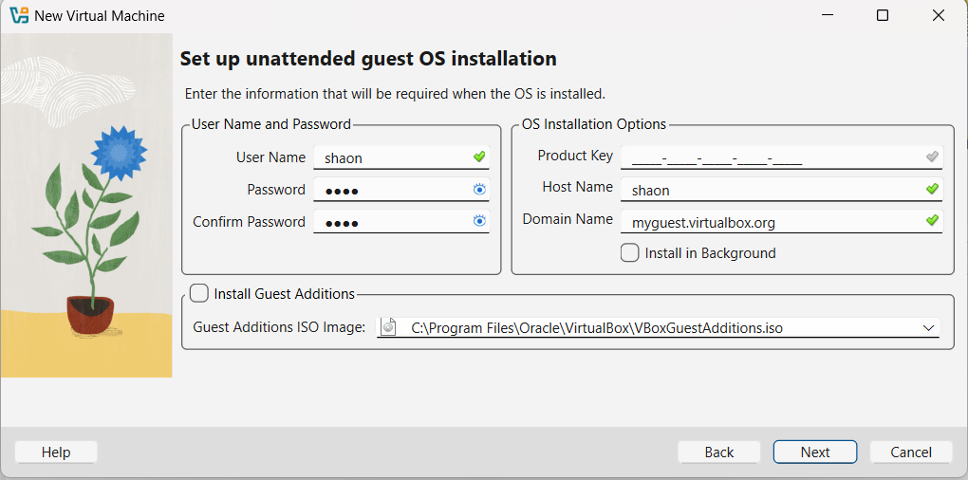
Figure 7: Unattended Guest OS Installation Setup
Here I set up the username and password for the Ubuntu installation. I entered "shaon" as the username and set a password. The host name was also set to "shaon". This step lets VirtualBox install Ubuntu automatically without needing manual input during setup.
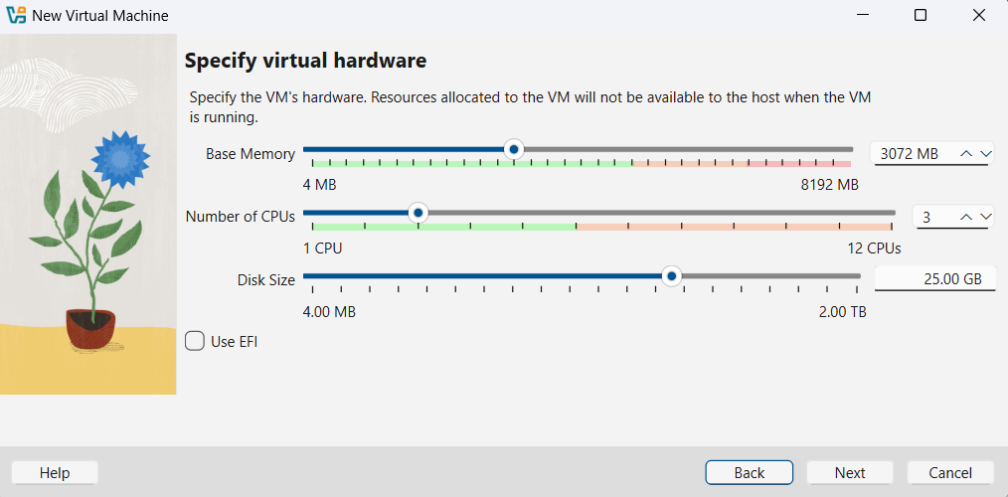
Figure 8: Virtual Hardware Configuration
This screen is for setting the virtual hardware. I assigned 3072 MB of RAM, 3 CPUs, and 25 GB of disk space for the virtual machine. These settings decide how much of the host computer resources the virtual machine can use.
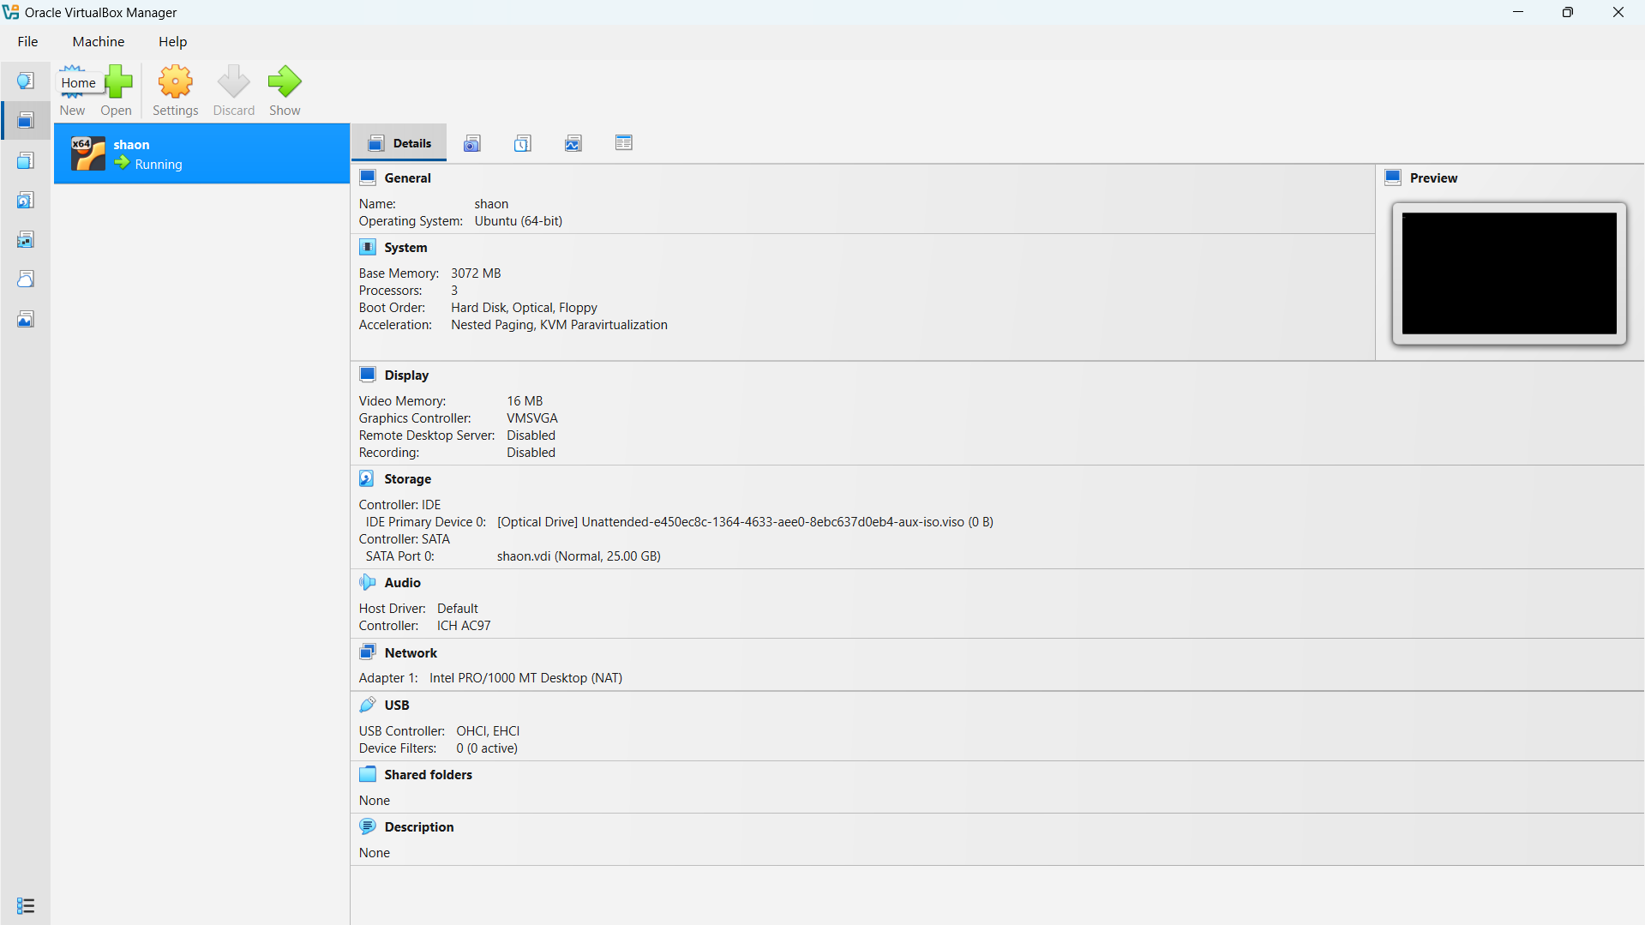
Figure 9: VirtualBox Manager – VM Details Overview
This is the Oracle VirtualBox Manager window showing the full details of the created virtual machine named "shaon". It shows the system info, storage, network adapter, audio, and USB settings. The VM status shows it is running.

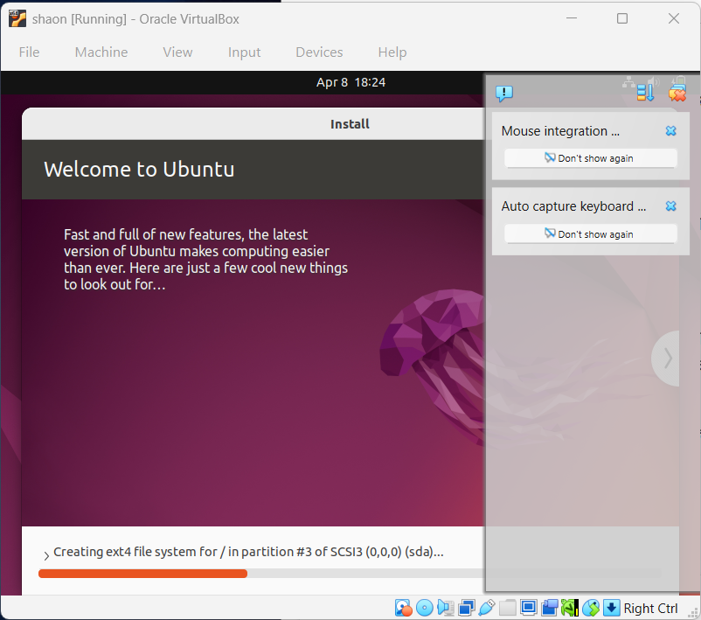
Figure 10: Ubuntu Installation in Progress

The virtual machine is now running and Ubuntu is being installed. The screen shows the "Welcome to Ubuntu" message and at the bottom it shows the progress – it is creating the ext4 file system on the virtual disk. The installation was running automatically.

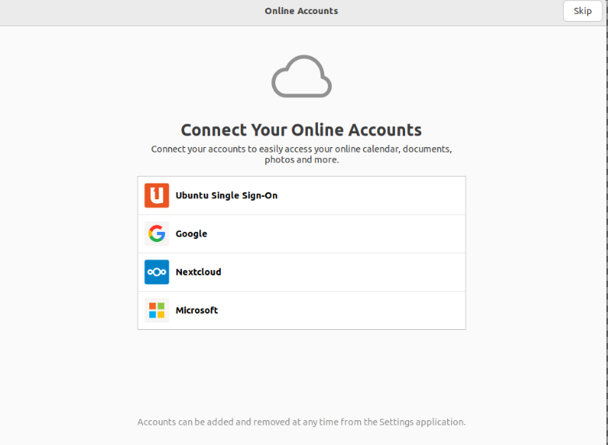
Figure 11: Ubuntu Online Accounts Setup Screen
After Ubuntu finished installing, this screen appeared asking to connect online accounts. It gives options to connect Ubuntu Single Sign-On, Google, Nextcloud, or Microsoft accounts.

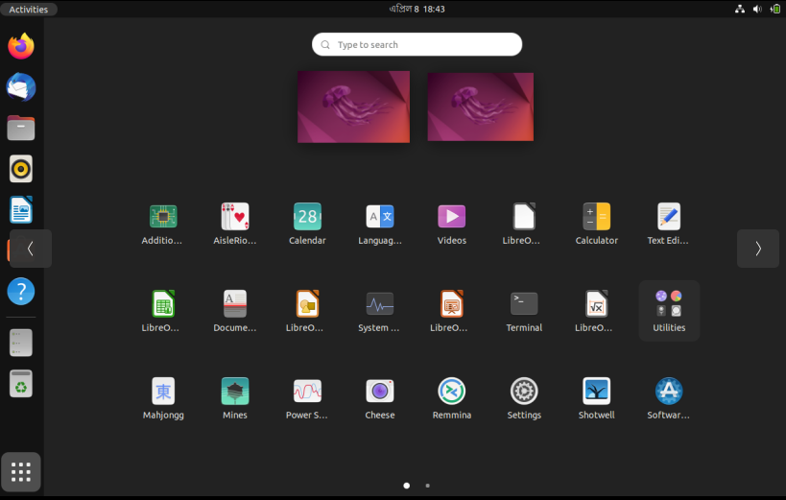
Figure 12: Ubuntu App Drawer – Installed Applications
This is the Ubuntu application drawer showing all the installed apps. I can see apps like LibreOffice, Calendar, Terminal, Calculator, Settings, and many more. This confirms that Ubuntu is fully installed and working inside VirtualBox.

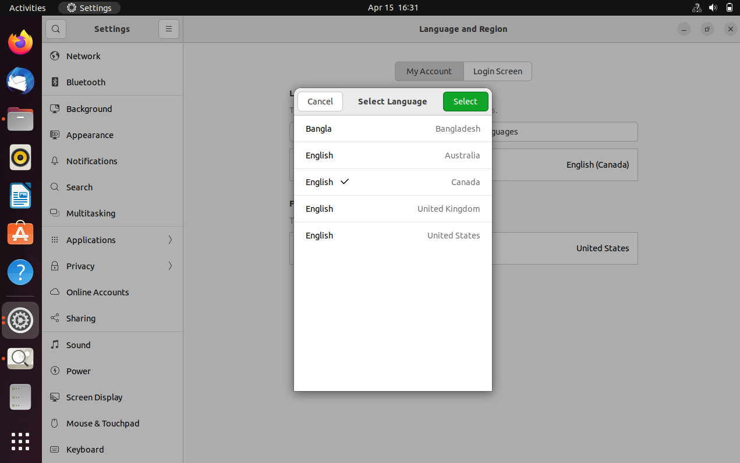
Figure 13: Language and Region Settings – Language Selection

This screen shows the Language and Region settings inside Ubuntu. I opened the language selection dialog and can see options like Bangla (Bangladesh), English (Australia), English (Canada), English (United Kingdom), and English (United States). I was checking the language settings after installation.

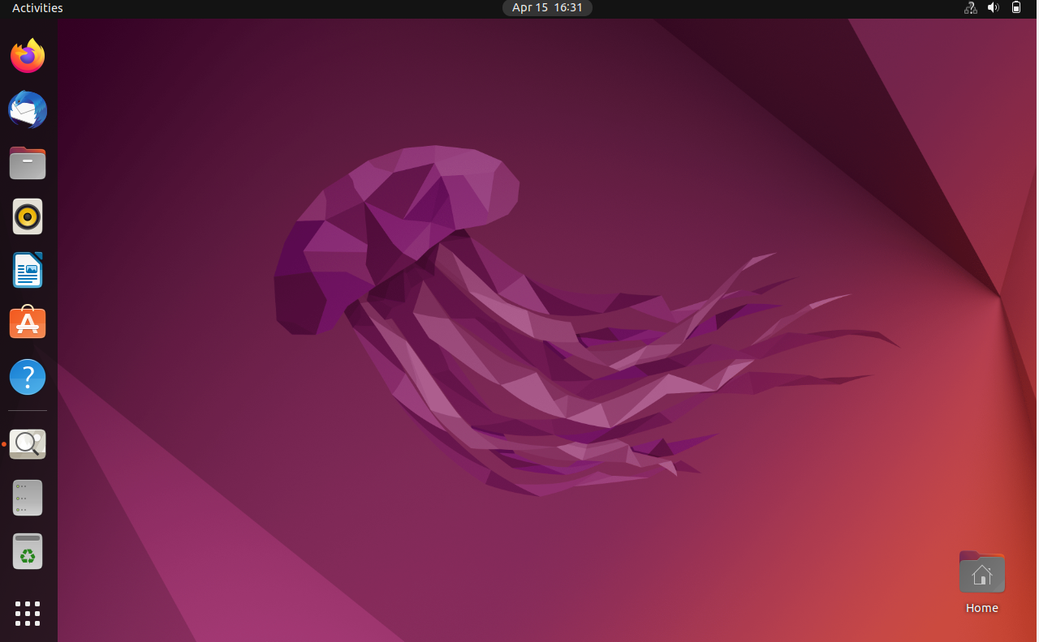
Figure 14: Ubuntu Desktop – Final View
This is the final Ubuntu desktop screen. The GNOME desktop is fully loaded with the default Ubuntu 22.04 jellyfish wallpaper. The taskbar on the left shows icons for Firefox, file manager, and other apps. This confirms that Ubuntu is successfully installed and running inside

Conclusion
I was able to successfully install Ubuntu 22.04.1 inside VirtualBox on my Windows computer. The process was a bit long but not very hard. First I downloaded VirtualBox and the Extension Pack. Then I created a new virtual machine and set the RAM, CPU, and disk size. After that I attached the Ubuntu ISO file and started the installation. VirtualBox installed Ubuntu automatically without needing me to click anything during the install. After the installation finished, I could see the Ubuntu desktop working properly inside VirtualBox. I also checked the app drawer and the language settings to make sure everything was fine. From this lab I learned how to use VirtualBox and how virtual machines work in general. It is a very useful tool for testing operating systems without changing anything on the main computer.

